# Further list challenges

## Part 2 – 2D arrays (list of lists)

1. Look up table. Create a 2D array of Music Band Facts.

|  |  |  |  |  |  |
| --- | --- | --- | --- | --- | --- |
| **Pos** | **Name** | **Formed** | **Origin** | **Style** | **Fans** |
| 0 | Metallica | 1981 | USA | Heavy thrash | 3700 |
| 1 | Gojira | 1994 | France | Prog Metal | 1300 |
| … etc | … | … | … | … | … |

Fans is a tricky number to find – think outside the box, how could you find this out?

Allow the user to enter a band name to find out facts.

Allow the user to choose a style and list all band with that style.

1. Write the statements needed to declare and load the following arrays.

2 4 1 5 2 7

A = 6 9 7 8 B = 3 7 9 C = 6 3

0 3 2 8 1 4 8 0 4

1. Use the arrays of question number 1 to answer the following question. Print the value of
2. A[1],[2]

(b) C[2],[1]

(c) B[0],[2]

(d) C[1],[2]

1. Write a function **flip_2d_list** that takes an array M on the left and converts it to, and returns, array N on the right. Array M must remain unchanged.

|  |  |
| --- | --- |
| 2 5 4 7  M = 3 1 2 9  4 6 3 0 | 2 3 4  N = 5 1 6  4 2 3  7 9 0 |

1. Write a function **sum_of_rows** that will take array M above and print the following output.

|  |
| --- |
| Row Sum of Row  1 18  2 15  3 13 |

1. Write a method **sum_of_cols** that will import array M from #1 and print the following output.

|  |
| --- |
| Column Sum of Column Entries  1 9  2 12  3 9  4 16 |

1. Times table. Using a 2D array fill it with the following:  
   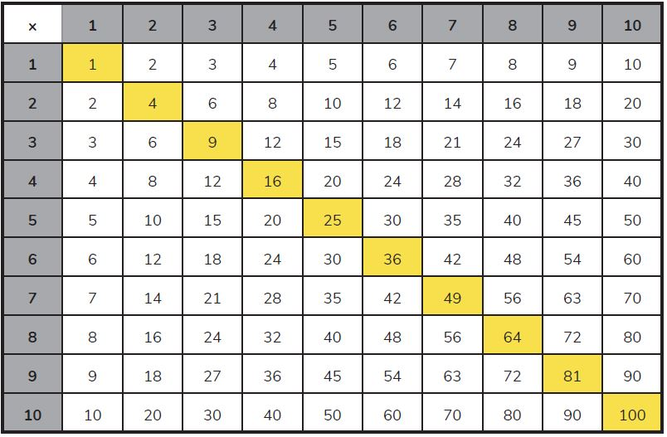  
   Print this out on the screen (with or without the yellow bits 😊 )
2. Code **battle ships**, user vs computer. Computer places ships on a grid. Use guesses locations, if it is a ship – hit! If it is ocean – miss! Keep score.
3. Create a list of lists (a grid), containing 40 x 40 space characters.  
   This is your ‘screen’, you can set ‘pixels’ on this grid to draw things:

Drawing the ‘screen’ by looping over the rows and columns drawing whatever character is in that position.